Chapter 18 Making music
Short investigation 18.1: Resonance in a closed pipe
Name:
Aim
To investigate the phenomenon of resonance in a closed pipe
Materials
Large glass measuring cylinder, thermometer, tuning fork (512 Hz), large rubber stopper, 40 cm long steel or glass tube (at least 3 cm diameter), water, ruler, felt pen.
Method
- Read the thermometer to determine the air temperature. Note this temperature in the Results section.
- Fill the measuring cylinder with water and lower the steel tube into it until its top is just above the water level.
- Strike the tuning fork on the rubber stopper to start the fork vibrating. Holding the vibrating fork over the mouth of the tube, slowly pull the tube out of the water.
- At the first point where the sound of the vibration is at its loudest, stop raising the tube. Use a ruler to measure the distance between the top of the tube and the water level. This is the first resonant length L₁ of the closed tube. Note this length in table 18.1A.
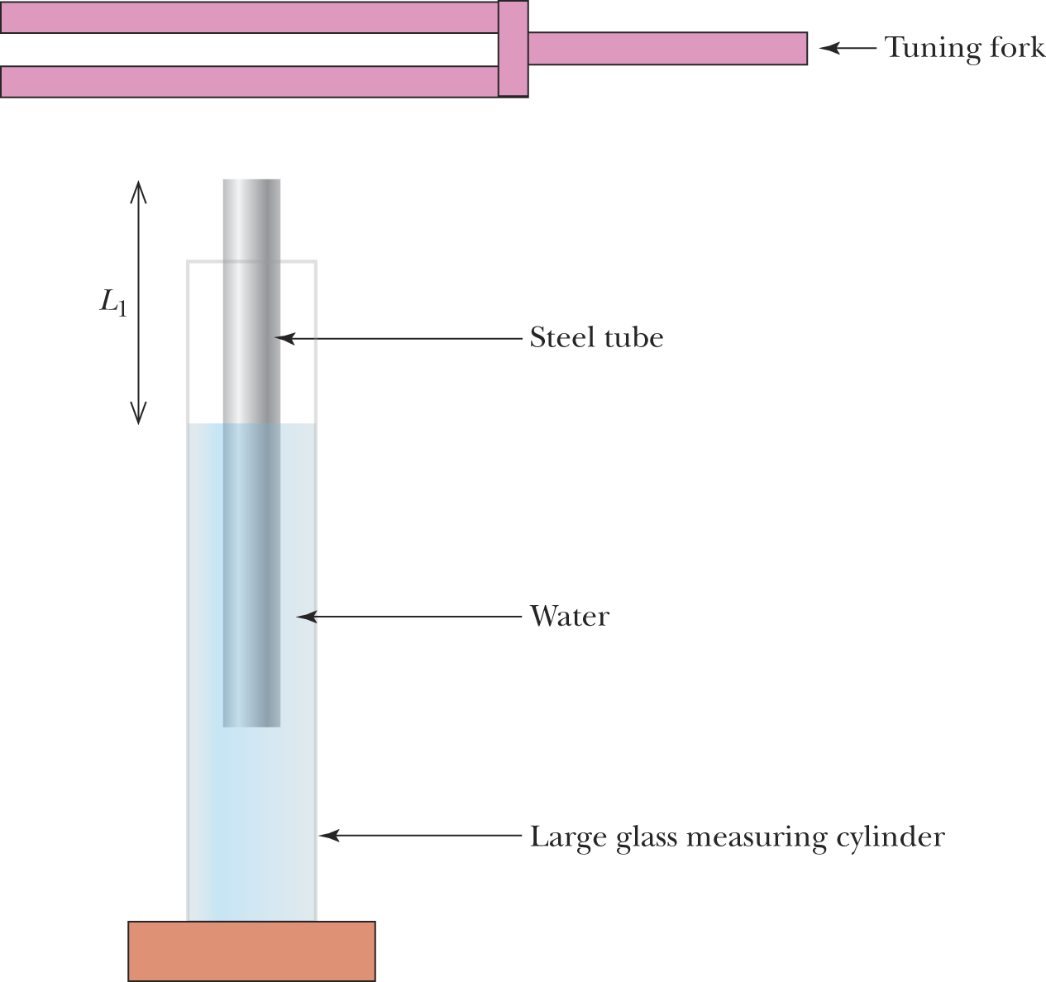

- Set the tuning fork vibrating again and hold it above the mouth of the tube while continuing to raise it from the water. When the sound of the tuning fork again becomes loudest, measure the distance between the water level and the top of the tube. This is the second resonant length L_{2.} Enter this value in table 18.1A.
- Repeat steps 3–5 twice more and determine the average values for L₁ and L₂.
Results
Air temperature = °C
Table 18.1A
Resonant length (m) | Trial 1 | Trial 2 | Trial 3 | Average
L₁
L₂

Analysing the results
- Using your measured value for air temperature and the equation $v=\text{331}\sqrt{\frac{T}{\text{273}}+1}$, determine the speed of sound for this investigation.
- For a closed pipe, the distance between resonant lengths is equal to half of the wavelength of the sound wave produced by the tuning fork, i.e. ΔL = L₂ – L₁ = $\frac{λ}{2}$.
- Use this equation and your average values for L₁ and L₂ in table 18.1A to determine the investigational value of the wavelength.
- Use your answers from questions 1 and 2 to determine the frequency of the vibration produced by the tuning fork.
- Compare your answer to question 3 with the tuning fork’s theoretical frequency of 512 Hz.
- Account for any discrepancies between the values.
Conclusion
State the relationship between the difference in resonant lengths in a closed tube and its frequency of vibration.
Notes:

